**NAME:- ADIL AHMAD**

**REGN No. :- 21BCE11394**

# A Short Story On Bullying

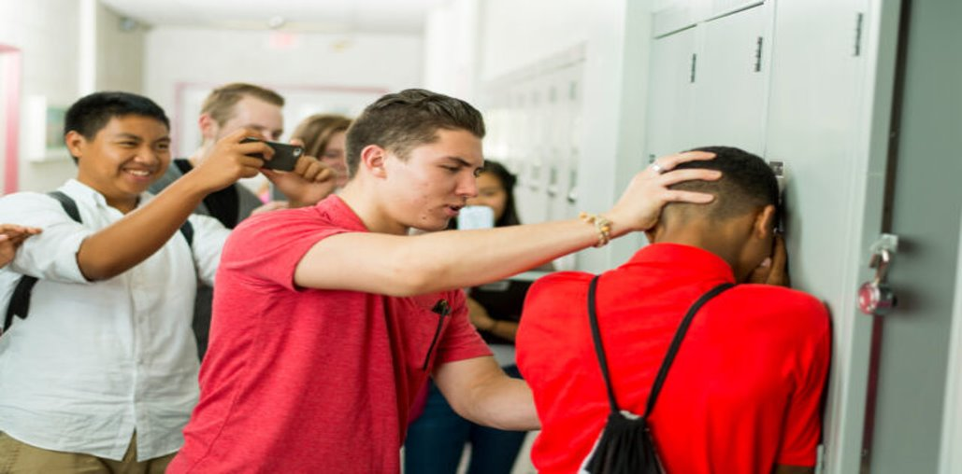

**Well, my name is Sam and I just turned 12 when I left elementary school and started secondary education. Going to school was not a good idea. At least not for me,**

**The first couple of months were doable. I didn’t have many, or any, friends in that school. Just a group of ‘other guys’ with which I shared some space and time, in class and at lunch hour. It took me quite a while to adapt to the new situation. I was the youngest, a new school, new children, for reasons I can’t recall the rest of my class were late 12 or just turned 13 years old. On top of that, I was quite skinny, too polite, raised well by my parents, a bit too well I guess and I still had a childish side in me. I was young for my age.**

**For those obvious reasons, they turned against me. They were a group of 6–10 guys. I wasn’t sure what I had done or didn’t do to them back then. What I was sure about was that I didn’t have a proper defense, not in any way, shape, or form. The moment ‘they’ turned against me, was the moment I turned into an ‘attacker’.**

**The three years that followed consisted of being chased around school, in class, in the yard, on my way to and from school- there was never a moment to catch a breath, never a moment where I could come to my senses, no protection or help at all from no one. I was alone, I was spit at, got cornered, kicked, and beaten up on a daily basis, sucked up the worst insults ever, had threats every other day or so, even to my life, and got publicly humiliated in several ways, was laughed at for the usual, stupid reasons, was ignored in various, humiliating ways, the list goes on and on.**

**One day my mother lay in the hospital for surgery that, if all went well, could heal her hernia. If it didn’t go well she might never walk again. We had some worries at home, so to say. During lunch hour in the auditorium of the school, one of the predators found out about it. I felt pressed to tell I was worried about the situation at home.**

**In an auditorium crowded with some three hundred students, he laughed at me once again, shouting real loud that I was lying and that my mother was hospitalized having cancer and was about to die. Upon which the rest of that group started laughing too of course. He apparently didn’t know we had cancer in our family.**

**It was the straw that broke the camel’s back. I somehow jumped on top of the table, and planted one of my feet in his face, in hindsight with so much force that he had the profile of my shoe almost carved in his face. A fully crowded auditorium turned silent at a moment’s notice and some three hundred pairs of eyes stared at me, standing on that table. My predator laid on his back, as he had fallen backward from his chair. One of the teachers dragged me from the table and angrily almost threw me into the principal’s office, where I was ordered to wait. With that action, he confirmed my belief that adults are the worst sort of traitors to children. Finally, I stood up for myself, only to find that I was cornered again and had to pay the price- in the form of a harsh conversation with the head of the school shooting at me that ‘violence was not allowed in school’ and ‘what the hell I was thinking kicking that poor boy in his face’.**

**But moments before that, between the fore-mentioned table and the Principal’s office my ‘Heroism’ vanished in thin air, and I, could mumble not much more than an apology.** **Well yes, mostly in hindsight. The bullying stopped for the last few months that were left of the 4 years that I was at that school. Later in life, I gained quite some knowledge on social structures and hierarchy, how human interaction works, both positive and negative, victimizing, and the importance of setting boundaries.**